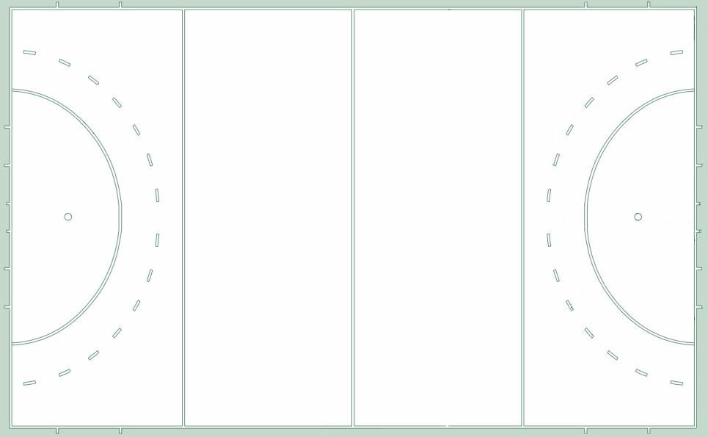

Pre-Match Chat
- Side: table/fans
- Time in/out: end of half, cards, injuries
- Areas of responsibility: sidelines, towards/away circle, middle of pitch
- Cooperation: looking for help, signaling the help, ask for consultation, take decision for unsighted, upgrade in 23m
- Management: cards/control ladder, going back after advantage played
- Positioning: PC, PS, deep opposite corner
- Signaling: advantage, play on, verbal
- Aerial balls, danger not raised, other interpretations
- Other technical issues: extra time, coin toss, ball people, pitch run-off
- Character/temper of game, team histories

